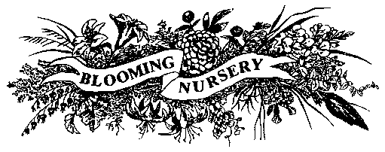
Blooming Nursery Pre-Pricing Preferences

Instructions: Fill out this form in Microsoft Word, save and email to prepricing@bloomingnursery.com or sales@bloomingnursery.com. If you have any questions, please contact your Blooming Nursery Sales Representative.
Customer Name:
Member of Northwest Nursery Buyers Association? Yes No

Contact name for Pre-Pricing Program:

Contact email for Pre-Pricing Program:
Tag Types (mark desired sizes, one tag type per size):

Stickers Sizes ($0.20 ea): 3.5” Qt RQt
Stickers Sizes ($0.20 ea): 1g 2g 3g 5g other larger sizes

Stick Tag Sizes ($0.15 ea): 3.5” Qt RQt
Stick Tag Sizes ($0.15 ea): 1g 2g 5g other larger sizes

Information on tag (all tags have plant name, size and customer name):

Print Customer Retail Price on Tag? Yes No

UPCs / SKU - Only one can be selected:

No UPC (barcode) or SKU

Blooming UPC (barcode) by item (unique to each item and size)

Customer UPC (barcode)

Customer SKU as Text

Customer SKU as a barcode

Blooming UPC (barcode) by item (unique to each item and size) & Customer SKU as
text

Customer UPC (barcode) & Customer SKU as text

